**I.S.M.BI**

***English***

**GSA**

|  |  |  |  |  |  |
| --- | --- | --- | --- | --- | --- |
| **ROLE** | **SURNAME** | **NAME** | **ID** | **E-mail** | **TEL/CEL** |
| Coordinador | Gularte | Gonzalo | 5420070-7 | gonzalogulartemvd@gmail.com | 094742318 |
| Sub-Coordinador | Iriart | Santiago | 5576229-3 | santiagoiriart9@gmail.com | 093982489 |
| Integrante 1 | Acosta | Agustin | 5213710-8 | agustin14acosta@gmail.com | 091027326 |
| Integrante 2 | Sunes | Bruno | 5258299-1 | brunosunes@gmail.com | 092111308 |
| Integrante 3 | Rosales | Zendhel | 6265313-4 | zendhelros@gmail.com | 096242702 |

Teacher: Meny, Alejandra

**Deadline:**

**09/11/2020**

**THIRD DRAFT**

Index

Cover1

Index2  
Requirement of the subject 3

Identificación de los integrantes **3**Informe sobre lo que se realizó en las asignaturas del área tecnólogica **4**Sugerencias de aportes**5**Actualización del informe **6**Abstract **8**Presentation Script **9**S.W.O.T Analysis **10  
Bibliography** **11**

**Requirements of the subject:**

Identificación de los integrantes de cada equipo de trabajo, los criterios que se siguieron para la conformación del grupo y explicación de los roles que se asignaron.

Criteria for the formation of the group:

We formed this group based on opinions, similar thoughts, a few friendships and the experience obtained the previous year of the groups for the final project. Its name reference to the initial letters of our names (Gonzalo Santiago Agustin).

Criteria for the roles:

Member Agustin Luciano Acosta Bernardo: Agustin thinks that it’s so much responsibility being a Coordinator or Sub-Coordinator, so he prefers to be just a member.

Member Bruno Daniel Sunes Pianavilla: Bruno started working with us because of the separation of his group. He didn’t have the opportunity to choose a role.

Sub-Coordinator Santiago Miguel Iriart Guibernau: Santiago chose this role because he likes the responsibility that it entails.  
  
Coordinator Gonzalo Lisandro Gularte Artola: He chose this role because he knows how to organize the documentation and the activities in order to achieve all the objectives in each phase of the project.

Informe sobre lo que se realizó para las asignaturas del área tecnológica con énfasis en “Formación Empresarial”.

Project management: The objective is to keep record about the rules, meetings and planify the time it should take to finish the project. To estimate that we use GANTT & PERT that are tools which help to calculate it.

Software analysis and design: The objective is to make an analysis of the program that we were asked to make and the main requirements that it must have. It has to be complemented with some “tools” like S.W.O.T analysis to know the strengths and weaknesses of the product and also of the business.

Operating Systems III: We have to choose an operative system with its version and a guide book to install it. We have to do a program which allows the user to create, modify and delete groups or users.

Programming III: The main objective is that we have to develop the graphic interface in every window without neglecting the code part.

Database Management Systems II: We have to do the ER Model (Entity-Relationship Model) which is a diagram that gives a complete view of the database in order to not make mistakes when making it.

Computer Maintenance & Computer Networks: Deberemos de seleccionar y fundamentar los equipos que se van a usar para los puestos de trabajo y para la sala de servidores, también se deben de ubicar en un plano de la institución médica que cuenta con planta baja y primer piso.

Business training: We have to create a business with general information about it such as the name (GSA) the partners etc. We also have to fill out a form of DGI-BPS to create the business and a contract to say that the business will be a public limited company.

Sugerencias de aportes específicos desde la asignatura inglés (tanto a partir de las inquietudes que los colegas hayan presentado a los alumnos como de los propios estudiantes) para optimizar la elaboración del software, así como su eventual comercialización.

We would like to work more on the vocabulary related to the software development industry.

Actualización del informe sobre lo que se realizó para las asignaturas del área tecnológica con énfasis en “Formación Empresarial”.  
 **Project management:** For this part, as the same as in the first one, the minutes of meetings and the GANTT Diagram, one for each subject and a total one, should be made only of the second part.

Then, the management documentation such as the planification and project control documentation will be made too, along with a contingency plan.

**Software analysis and design:** In this second part of the project we need to do the cost-benefit analysis. It's a way to know if the IT System is a good inversion to the organization. Some diagrams have to be made, such as, “UML Diagrams” “Nassi-Schneiderman Diagrams” “State Diagrams” “Warnier-Orr Diagrams” “Use Case Diagrams” It helps in the future of the development in our system.

**Operating Systems III:** For this part, the internet configuration in terminals and in the server is going to be made, along with the configuration of the users creation with his corresponding permits. To end with, some scripts about the automation of different processes such as backups will be made too.

**Programming III:** In this second part of the project, we need to coding the connection between the app and the database. The app programmed will be used to make all CRUD modifications (Create, Read, Update, Delete) for the data entered by the users of the system.

**Database Management Systems II:** In the second part of the project, the database physical model will be implemented, here all the entity and relation tables that were made with SQL sentences is where they will be, in turn, a study about the database users permissions will be made, so then, implement them in the physical model that was created before.

**Business training:** In this second part of the project we will design two plans: Strategic Plan and Operative Part.

The Strategic plan will detail the vision and the mission of our organization.

The vision gives information about our ethical values and our mission details our aims as a business. On the other hand, the operative plan details which human resources we have and the inversions that we will have to assigned to the develop of the entrepreneurship

**Computer Maintenance & Computer Networks:** In this second part of the project we will do an analysis about the service which will be provided by the business that bought the software, the documentation and structured cabling that will be implemented.

Later, we will need to know the material needed to implement the net and the Computer Equipment.

**Sociology:** For this part, we have to interview a doctor with questions about diagnostics, diseases and the software and then transcribe the oral interview so we can use the information collected to support us and help the development of the software to be according to the requirements of a health professional.

Abstract

This product is aimed at public and private health institutions of Uruguay and the region, also, it was designed from the study of functional and nonfunctional requirements together with other analysis and design tools.

The developed system offers different functionalities to patients, doctors and medical auxiliaries, such as admission and consultation of a interview between a patient and a doctor, also, it gives the opportunity to enter, modify, delete and consult clinic analyses, treatments and diagnoses made by a patient in the medical institution. It also provides the option to manage forms by allowing medical staff to add and delete forms as well as, enter, modify and delete questions and then add answers to them.

Once the interview between the patient and the doctor has finished, the system suggests possible illnesses.

If the doctor thinks that the suggestion is not good, he can do a diagnoses of the patient and if it is necessary enter an clinical analysis to verify that matches the diagnoses.

The system validates the type and size of data it helps not to enter wrong information.

To make possible this functionalities a connection between the program and the database is needed.

To put the program in a work area is necessary to have the IT devices infrastructure previously installed. That will allow the user to use the system and will allow others activities in the medical institution.

The price of the product has been established using the Function Point Analysis, also the cost-benefit relation and the time we had to develop the software.

Presentation script

To implement the software, it’s necessary to implement the infrastructure to be used and that will allow other activities in the medical institution. Workstations and access points will be installed for the patients and their companions, one server for the database, another one for the backups and other for the web and mail used by the institution. To keep the network and workstations secure, measures will be taken, for example, a antivirus for the workstations and servers, the creation of users with the permissions only to do what they’re allowed to, the configuration of the firewall in the servers, the creation of virtual networks to prevent the access of unwanted parts of the network, the amount of workstations that can be connected to the network were limited and a router firewall was implemented which can allow or deny the access to the medical institution network.

To achieve the objective, it is necessary to carry out a metrics study to determine the costs and price of the product and then carry out a cost-benefit analysis of the project to decide whether it is worth or not to invest in it.

Also, to achieve the objective of developing the system, we need to use planning, analysis and design tools, such as C.A.S.E (Computer-Aided Software Engineering) that contribute to the development of the product.

Finally, the results of our project will be reflected in the functionality, reliability, robustness and performance provided by our computer system.

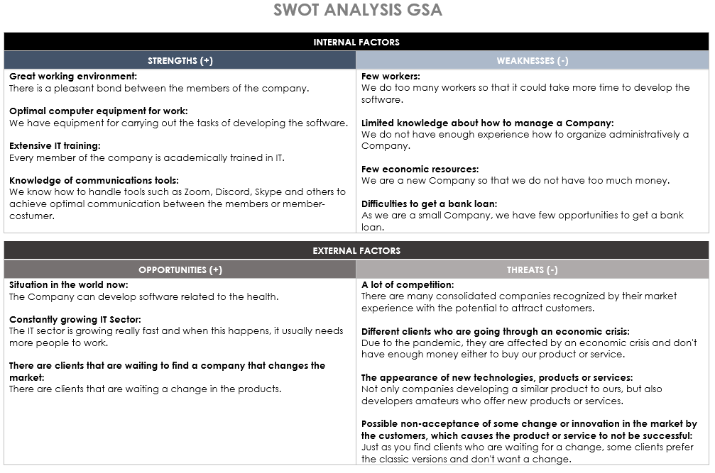S.W.O.T Analysis

**Bibliography**

Class notes given by Alejandra Meny